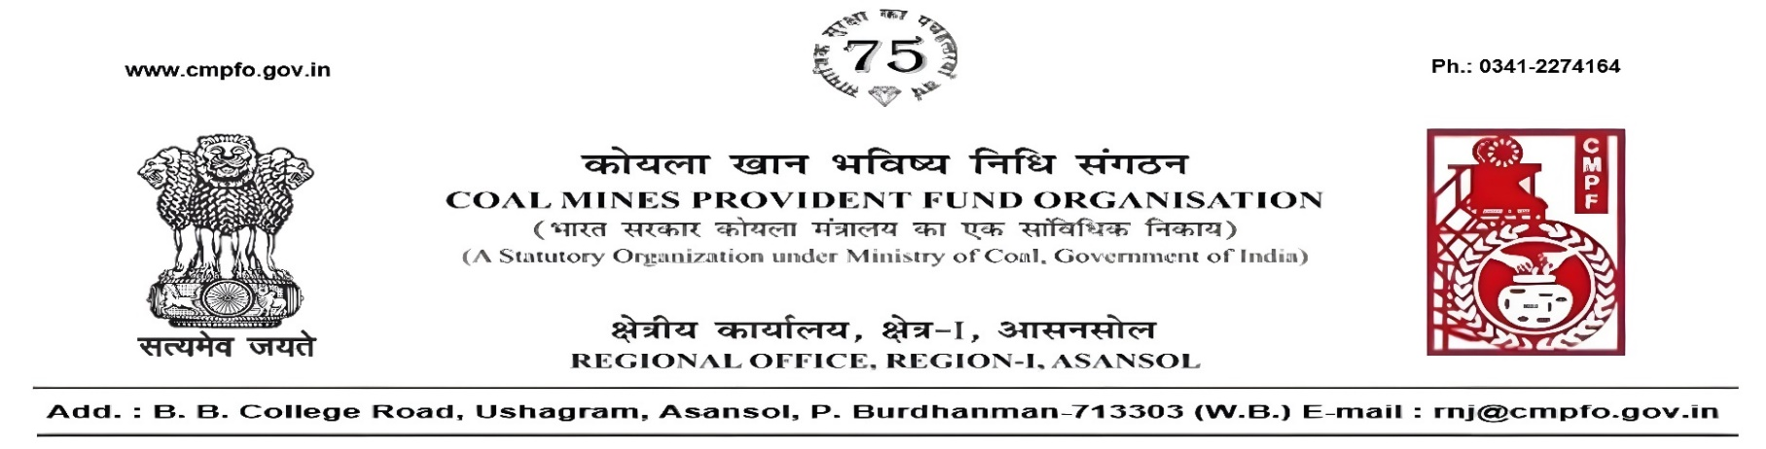
CPF/118/Misc./L.C.-Req./R-I/ASN/ Date-17/08/2026

To
The Regional Commissioner
Coal Mines Provident Fund
Police Line
Dhanbad , D-I & II
Dhanbad (Jharkhand)
PIN-826014

Sub:- Inter Regional Transfer of Ledger Card in respect of Mr. Sanjay Kumar Singh, CMPF a/c No.- RMG/41/179.

Ref:-CPF/BLP/73/L.C.-Req./417 & BLP/65/420 dated 08/06/2026.

Sir,
In view of the revised Procedures prescribed in Procedure Office Order No-35, Dated 12.02.1975 of CMPF Commissioner, Dhanbad, it is stated that the Ledger Cards of the following members along with Declaration in Form A, PS-3 & PS-4 and details of pension contribution may kindly be forwarded to this office in respect of Mr. Sanjay Kumar Singh, CMPF a/c No.- RMG/41/179 working in this region.
It may kindly be ensured that the posting in the Ledger Cards have been made/updated for the periods the member was working in this Region.
In case, the Ledger Card(s) already transferred from your Region, the Region to whom transferred, indicating the details of transfer and your letter number and date be intimated.

SL. No | Place of Posting | From | To | Regional office
1 | Lodna Colliary (Lodna Area )BCCL | 08/2007 | 08/2015 | Dhanbad
2 | Amalgated Samdih Patherdih Incline (Bhowra Area)BCCL | 08/2015 | 03/2023 | Dhanbad
3 | Bhowra (s) Colliery (Bhowra Area)BCCL | 03/2023 | 06/2024 | Dhanbad
Please acknowledge the receipt of the above at the earliest.
Yours faithfully,

(Ajay Kumar Singh)
Regional Commissioner - I

